**Industrial Internship Report on**

**”Healthcare data management system”**

**Prepared by :**

Ganji Karthik(ganjikarthik321@gmail.com)

|  |
| --- |
| *Executive Summary* |
| This report provides details of the Industrial Internship provided by upskill Campus and The IoT Academy in collaboration with Industrial Partner UniConverge Technologies Pvt Ltd (UCT).  This internship was focused on a project/problem statement provided by UCT. We had to finish the project including the report in 6 weeks’ time.  My project was (Healthcare data management system)  This internship gave me a very good opportunity to get exposure to Industrial problems and design/implement solution for that. It was an overall great experience to have this internship. |

**TABLE OF CONTENTS**

1 Preface 3

2 Introduction 10

2.1 About UniConverge Technologies Pvt Ltd 10

2.2 About upskill Campus 15

2.3 Objective 17

2.4 Reference 17

2.5 Glossary 18

3 Problem Statement 18

4 Existing and Proposed solution 19

5 Proposed Design/ Model 21

5.1 High Level Diagram (if applicable) **Error! Bookmark not defined.**

5.2 Low Level Diagram (if applicable) **Error! Bookmark not defined.**

5.3 Interfaces (if applicable) **Error! Bookmark not defined.**

6 Performance Test 22

6.1 Test Plan/ Test Cases 22

6.2 Test Procedure 23

6.3 Performance Outcome 26

7 My learnings 27

8 Future work scope 27

# Preface

Summary of the whole 6 weeks’ work.

Week 1: Project Kickoff and Problem Definition

During the first week, the project team was assembled, and the problem statement was defined. The key objectives were established, including the development of a Healthcare data management system capable of providing data to patients and doctors. The team also discussed data requirements and challenges.

Week 2: Data Collection and Preprocessing

In the second week, efforts focused on gathering a diverse dataset of patient’s data and abnormality he/she has.

Week 3: System Design and Development

In the third week, Created a detailed system architecture that outlines the components and their interactions. Designed and implemented the storage system for medical data including encryption and data retrieval mechanisms considering security and scalability. Implemented the blockchain user interface platform for providers and patients and smart contract logic for data access and management.

Week 4: Testing and Deployment

In forth week, Conducted thorough testing including unit testing, integration testing, security testing and performance testing to assess scalability and ensured whether the healthcare is with data privacy regulations. Deployed the platform in a secure and compliant environment, Established backup and disaster recovery procedures.

Week 5: Monitoring and Maintenance

In fifth week, Implemented continuous monitoring for security threats and system performance, provided on-going maintenance and updates to address issues and improve functionality. Updated with evolving healthcare and blockchain regulations.

Week 6: Security and Data Protection

In sixth week, Continuosly updated security measures to address new threats, regularly audit and assess data protection mechanisms.

**Project Conclusion and Next Steps:**

“We did it! We created a special system to take care of all the important information about patients. It’s like a safe home for their records. We made sure everything follows the rules to keep it private and secure.We asked people to try it out and they told us what they liked and what could be better. We listened and made it even better!Our system is strong and can handle lots of information without getting slow. And guess what? It can grow and get even smarter in the future.We showed everyone how to use it and made a little book to help. We promise to always follow the rules to keep healthcare info safe

Next Steps:

Now, we’ll keep an eye on our system to make sure it’s always working well. If there’s something to fix or make better, we’ll do it! We’ll also keep learning and thinking of new ways to make our system even more helpful.And who knows? Maybe one day, we’ll make it even more amazing than it already is. Thanks to everyone who helped us get here!”

**Healthcare data management system**

**Problem Statement:**

In the current healthcare environment, managing patient data efficiently and securely has become a significant challenge. Existing systems often lack the necessary safeguards to ensure the privacy and confidentiality of sensitive medical information. Additionally, the increasing volume of data generated by healthcare facilities, coupled with the need for seamless interoperability between different systems, has led to inefficiencies and potential risks in data management.

The goal of this project is to design, develop, and implement a healthcare data management system that overcomes these challenges, providing healthcare professionals with a reliable, user-friendly platform for storing, accessing, and sharing patient information securely. By doing so, we aim to enhance the efficiency of healthcare operations while safeguarding the confidentiality and integrity of sensitive medical data.”

**Project Objectives:**

The main objectives of this project are as follows:

Enhance Data Security and Privacy: Implement robust security measures to safeguard patient information and ensure compliance with healthcare data protection regulations like HIPAA.

Improve Data Accessibility: Create a user-friendly interface for healthcare professionals to easily access and retrieve patient records, promoting faster and more accurate decision-making.

Optimize Data Storage and Retrieval: Develop a system that efficiently stores and retrieves large volumes of medical data, minimizing processing times and resource usage.

Scale for Future Growth: Design the system architecture to be scalable, allowing it to accommodate increased data volumes and user loads as the healthcare facility expands.

**Data Requirements:**

Patient Demographics:Name,Date of Birth,Gender,Contact Information (Address, Phone Number, Email)

Medical History:Allergies,Past Illnesses and Conditions,Family Medical History,Medications

Clinical Observations:Vital Signs (Blood Pressure, Heart Rate, Respiratory Rate),Height and Weight,Body Mass Index (BMI),Temperature

Diagnostic Data:Laboratory Test Results,Imaging Studies (X-Rays, MRI, CT Scans),Pathology Reports,ECG and Other Test Results

Treatment Records:Prescribed Medications,Surgeries and Procedures,Therapies and Interventions

Appointment and Scheduling Information:Appointment Dates and Time,Attending Physician or Healthcare Provider

Insurance and Billing Information: Insurance Provider Details,Policy Number,Billing and Payment Records

**Challenges:**

Several challenges need to be addressed in this project:

Keeping Information Safe: Making sure that patients’ private information is kept secure and not accessible to unauthorized people.

Making Different Systems Work Together: Getting different computer systems in a hospital to talk to each other and share information.

Handling Lots of Information: Dealing with a huge amount of data from patients, like their medical history and test results.

Following Rules and Laws: Making sure the project follows all the special rules and laws about healthcare data.

Dealing with Old Technology: Figuring out how to use and connect old computers and software with new ones.

Making Sure Data is Correct: Checking that the information in the system is accurate and up-to-date.

Training People to Use the System: Teaching doctors and nurses how to use the new computer system effectively.

Planning for Emergencies: Making a plan for what to do if something goes wrong, like a power outage or a computer problem.

Being Careful with Money: Using the budget wisely, so the project doesn’t cost too much.

Using Data for Good: Using the information in a way that helps patients and follows ethical guidelines

**Deliverables:**

The final deliverables for this project include:

Moving Data Plan: A plan for safely moving information from old computers to the new system.

Teaching Materials: Stuff like videos or presentations to help doctors and nurses learn how to use the new system.

Proof of Safety: Papers showing that the system follows all the rules and keeps patient information safe.

Test Results: Papers showing that the system was checked and works properly.

Security Rules: Information about how the system keeps patient info safe from people who shouldn’t see it.

**Impact:**

Better Care for Patients: Helps doctors and nurses have the right information about patients, so they can treat them better.

Less Paperwork, More Time with Patients: Reduces the amount of paperwork, giving doctors and nurses more time to take care of patients.

Easier Sharing of Information: Makes it simple for different parts of the hospital to share important information about patients.

Fewer Mistakes: Makes sure that the information about patients is accurate, which means fewer mistakes in their care.

Quick Help in Emergencies: Gives fast access to crucial info in emergencies, so patients get the help they need right away.

Following Rules and Laws: Helps the hospital follow all the important rules about keeping patient information safe and private.

Learning from Data: Helps doctors and hospitals learn from the information they have, so they can make care even better.

Patients Can be More Involved: Lets patients see their own information and be more involved in their care.

Saving Money: Helps hospitals use their money wisely by reducing waste and unnecessary costs.

Planning for Tough Situations: Helps hospitals be ready for emergencies or tough situations that might happen.

In short, it makes healthcare better, safer, and more efficient for everyone involved!

Opportunity given by USC/UCT.

How Program was planned

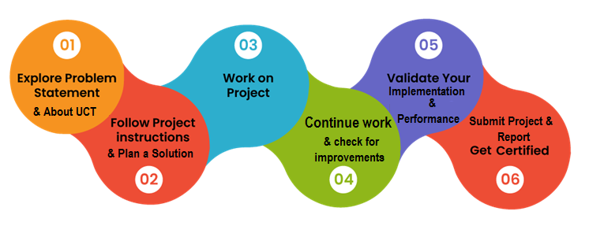

Your Learnings and overall experience.

Through this project, I have gained valuable insights into:

- Machine learning model development and deployment.

- Data preprocessing and augmentation techniques.

- Real-world constraints in industrial applications.

- The importance of accuracy, efficiency, and sustainability in agricultural technology.

These learnings will significantly contribute to my career growth in data science and machine learning

Thank to all (with names), who have helped you directly or indirectly.

We Thank to Our mentors and Friends who helped us for sharing DataSets,and Guiding us to complete project.

Your message to your juniors and peers.

Dear Juniors and Esteemed Peers

I hope this message finds you in good health and high spirits. Today, I want to share with you an inspiring vision and a profound sense of purpose. I want to talk about the Crop and Weed Detection project we are embarking on, and I want to convey a message that goes beyond just words—it's a rallying cry, a call to action, and a testament to what we can achieve together.

Our mission is to create a Crop and Weed Detection system that has the potential to revolutionize agriculture and address one of the most pressing challenges of our time: feeding a growing global population while preserving our precious environment. This project isn't just another item on our to-do list; it's a calling, a responsibility, and an opportunity to make a tangible, positive impact on the world.

Here are the reasons why this project matters, and why we must pour our hearts and souls into it:

1. Global Food Security: As we speak, millions of people around the world are facing hunger. Our work can contribute to increasing crop yields, ensuring that more mouths are fed, and livelihoods are secured.

2. Sustainability:Our project aligns with the principles of sustainable agriculture. By accurately detecting crops and weeds, we can reduce the need for excessive pesticide use, benefiting the environment and ecosystems.

3. Innovation: We have the chance to push the boundaries of technology and innovation. The solutions we develop will have real-world applications and might just shape the future of farming.

Now, let's not kid ourselves. This project won't be a walk in the park. We'll encounter challenges—technical, logistical, and perhaps even personal. But remember, it's precisely in overcoming these obstacles that we grow, both as individuals and as a team.

I urge you to embrace this project with unwavering dedication. Let's:

- Dive deep into the problem, understand it from every angle, and use our collective intelligence to find innovative solutions.

- Collaborate closely, support one another, and foster an environment of trust and respect.

- Push ourselves to deliver results that are not just good but outstanding. Let's set the bar high and exceed our own expectations.

- Keep the bigger picture in mind. Our work here can contribute to something much greater than ourselves.

# Introduction

## About UniConverge Technologies Pvt Ltd

A company established in 2013 and working in Digital Transformation domain and providing Industrial solutions with prime focus on sustainability and RoI.

For developing its products and solutions it is leveraging various**Cutting Edge Technologies e.g. Internet of Things (IoT), Cyber Security, Cloud computing (AWS, Azure), Machine Learning, Communication Technologies (4G/5G/LoRaWAN), Java Full Stack, Python, Front end**etc.

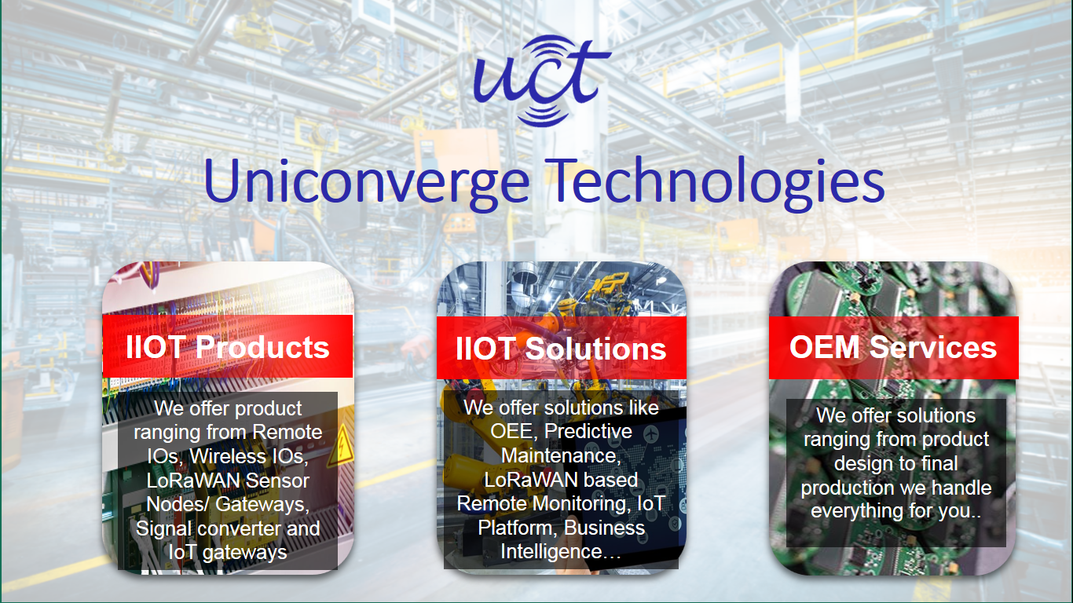

1. UCT IoT Platform **(****)**

**UCT Insight** is an IOT platform designed for quick deployment of IOT applications on the same time providing valuable “insight” for your process/business. It has been built in Java for backend and ReactJS for Front end. It has support for MySQL and various NoSql Databases.

* It enables device connectivity via industry standard IoT protocols - MQTT, CoAP, HTTP, Modbus TCP, OPC UA
* It supports both cloud and on-premises deployments.

It has features to  
• Build Your own dashboard  
• Analytics and Reporting  
• Alert and Notification  
• Integration with third party application(Power BI, SAP, ERP)  
• Rule Engine

 

1. **Smart Factory Platform (****)**

Factory watch is a platform for smart factory needs.

It provides Users/ Factory

* with a scalable solution for their Production and asset monitoring
* OEE and predictive maintenance solution scaling up to digital twin for your assets.
* to unleased the true potential of the data that their machines are generating and helps to identify the KPIs and also improve them.
* A modular architecture that allows users to choose the service that they what to start and then can scale to more complex solutions as per their demands.

Its unique SaaS model helps users to save time, cost and money.

 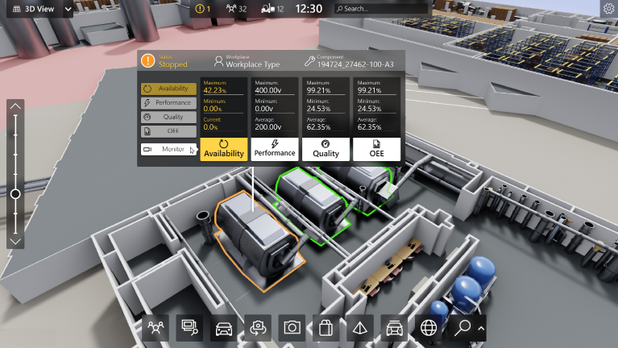

1. 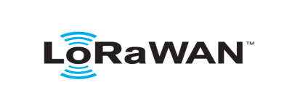 based Solution

UCT is one of the early adopters of LoRAWAN teschnology and providing solution in Agritech, Smart cities, Industrial Monitoring, Smart Street Light, Smart Water/ Gas/ Electricity metering solutions etc.

1. Predictive Maintenance

UCT is providing Industrial Machine health monitoring and Predictive maintenance solution leveraging Embedded system, Industrial IoT and Machine Learning Technologies by finding Remaining useful life time of various Machines used in production process.



## About upskill Campus (USC)

upskill Campus along with The IoT Academy and in association with Uniconverge technologies has facilitated the smooth execution of the complete internship process.

USC is a career development platform that delivers **personalized executive coaching** in a more affordable, scalable and measurable way.



Seeing need of upskilling in self paced manner along-with additional support services e.g. Internship, projects, interaction with Industry experts, Career growth Services

<https://www.upskillcampus.com/>

upSkill Campus aiming to upskill 1 million learners in next 5 year

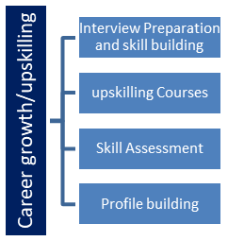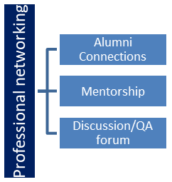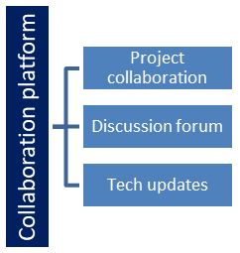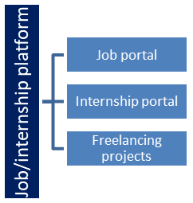

## The IoT Academy

The IoT academy is EdTech Division of UCT that is running long executive certification programs in collaboration with EICT Academy, IITK, IITR and IITG in multiple domains.

## Objectives of this Internship program

The objective for this internship program was to

 ☛ get practical experience of working in the industry.

 ☛ to solve real world problems.

 ☛ to have improved job prospects.

 ☛ to have Improved understanding of our field and its applications.

 ☛ to have Personal growth like better communication and problem solving.

## Reference

Ganji Karthik(ganjikarthik321@gmail.com). “Healthcare data management system”.

GitHub Repository:,2023.

## Glossary

|  |  |
| --- | --- |
| Terms | Acronym |
| Cloud | Where we can store the data of patient’s and medical records. |
| IBM Blockchain Platform | Gives us total control of our blockchain network with a user interface. |
| Kubernetes | Creates a cluster of compute hosts and deploys highly available containers. |
| Docker | It is a computer program that performs operating system level virtualization also known as containerisation. |
| Problem Statement | A clear and concise description of the issue or challenge that this project aims to address. |
| Existing Solution | Old solution is to enter data manually and we cannot access faster. |
| Proposed Solution | The new approach or system being developed in this project. |
| Value Addition | The benefits and improvements the proposed solution offers compared to existing solutions. |
| Model | IBM cloud is used to build this project . |
| Performance Test | Evaluation of the proposed solution's performance against predefined metrics. |
| Constraints | Limitations or restrictions on the project, which may include accessibility and inclusivity , compatibility, security and privacy. |
| Testplan/Test Cases | A documented plan outlining the testing approach and specific test cases. |
| Test Procedure | The step-by-step instructions for executing the test cases. |
| Performance Outcome | The results of the performance tests conducted. |
| Learnings | Key takeaways and insights gained during the project. |
| FutureWork Scope | Future Work Scope*: Ideas and potential enhancements for future iterations of the project. |

# Problem Statement

Problem Statement:

Current healthcare records are scattered, leading to delays, errors, and inefficiencies. We need a unified system to securely store, organize, and share patient data, ensuring accurate treatment and improved operational effectiveness.

Problem Description:

Currently, healthcare data is fragmented across various systems, leading to confusion and delays in patient care. Retrieving accurate information is a challenge, potentially affecting diagnoses and treatments. A centralized data management system is needed to ensure seamless access, data integrity, and efficient healthcare delivery.

# Existing and Proposed solution

**Summary of Existing Solutions:**

* The way we handle healthcare data now has some problems. The information is spread out in different places, making it hard to get a complete picture of a patient’s health. Sometimes, the systems don’t talk to each other, causing delays. People still have to type in data by hand, which can lead to mistakes. Patients also don’t have easy access to their own records. This system has been around for a while and needs some improvements.

Limitations of Existing Solutions:

Fragmented Data Sources: Data is often stored in separate silos or systems, making it challenging to access a comprehensive view of a patient’s medical history.

Lack of Interoperability: Existing systems may not communicate well with each other, hindering seamless data exchange between different healthcare providers and facilities.

Manual Data Entry: Healthcare professionals may still rely on manual data entry, which is time-consuming and introduces the risk of human error.

Limited Accessibility for Patients: Patients may have limited access to their own health records, which can hinder their ability to actively participate in their own care.

Inconsistent Data Standards: Different systems may use varied coding and terminology standards, leading to potential discrepancies in data interpretation

What is your proposed solution?

Proposed Solution:

A healthcare data management system is a secure digital platform designed to efficiently store, organize, and analyze patient information. It ensures quick access to medical records, facilitates communication between healthcare providers, and safeguards sensitive data. The system employs encryption and strict access controls to protect patient privacy. Additionally, it integrates with various medical devices and software for seamless data exchange. Regular backups and disaster recovery plans are implemented to prevent data loss. Overall, it streamlines healthcare operations, enhances patient care, and maintains compliance with regulatory standards.

What value addition are you planning?

* Predictive Analytics: The system will employ advanced analytics and machine learning algorithms to help predict patient outcomes, identify at-risk individuals, and optimize treatment plans.
* Interoperability: It will be designed to seamlessly integrate with other healthcare systems and technologies, allowing for smoother data exchange between different platforms and provider.
* User-Friendly Interface: We prioritize an intuitive and user-friendly interface to ensure that healthcare professionals can easily navigate and utilize the system without extensive training.

## Code submission (Github link): https://github.com/Karthiiik546/upskillcampus.git

## Report submission (Github link) :

# Proposed Design/ Model

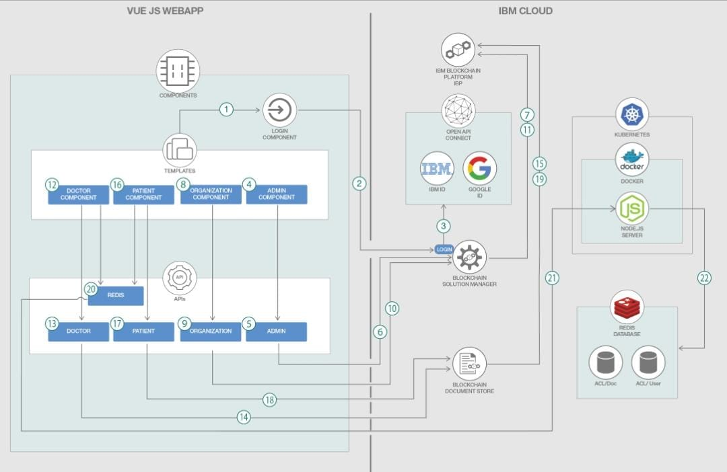

# Performance Test

[Here we need to first find the constraints.

How those constraints were taken care in your design?

What were test results around those constraints?]

Constraints can be e.g. memory, MIPS (speed, operations per second), accuracy, durability, power consumption etc.

In case you could not test them, but still you should mention how identified constraints can impact your design, and what are recommendations to handle them.

The project may face the following constraints:

1. Accessibility and Inclusivity: The system should be designed to accommodate users with different abilities, ensuring that it’s accessible to all individuals, including those with disabilities.
2. Interoperability: It’s crucial for healthcare systems to be able to exchange information with other systems, both within and outside the organization. Standards like HL7 (Health Level Seven) and FHIR (Fast Healthcare Interoperability Resources) play a significant role in achieving this.
3. Compatibility and Integration: The system may need to work with existing healthcare IT infrastructure, including electronic health records (HER) systems, laboratory information management systems (LIMS), and more.
4. Security and Privacy: Patient data must be protected against unauthorized access or breaches. Robust encryption, access controls, and secure authentication mechanisms are essential.

## Test Plan/ Test Cases

A comprehensive test plan will be developed, including the following aspects:

1. Accessibility and inclusivity with users individually.
2. Interoperability to exchange data.
3. Compatability for every record or data.
4. Security for patients data.

## Test Procedure

* **Preconditions:**
  + Setup your machine
  + Create IBM cloud services
  + Create a solution
  + Clone the repository
  + Modify the configuration files
  + Run the application
* **Procedure:**
  + - 1. Set up your machine:

Install the following dependencies –

Docker: Go to the Docker website and download the installer. After installation, run Docker.

Git: Install git which is a free and open source distributed version control system.

2.Create IBM cloud services:

Create the IBM Cloud Kubernetes Service. You can find the service in the Catalog. For this code pattern, we can use the Free cluster, and give it a name. Note, that the IBM Cloud allows one instance of a free cluster and expires after 30 days.

Create the IBM Blockchain Service. You can find the service in the Catalog.

Create the Blockchain document store and Blockchain solution manager services. These services are not currently available publicly on the IBM cloud catalog. You can reach out to Rak-Joon Choi ([rak-joon.choi@us.ibm.com](mailto:rak-joon.choi@us.ibm.com)) to provision these services for you. Follow the service documentation to connect the Blockchain document store to the Blockchain service.

3.Create a solution:

After configuring your services in the previous step, we now move on to creating a solution using our custom swagger url for the blockchain solution manager service. Go to the Patch endpoint (/v1/solutions) under Solution and authorize using the api by going to the /v1/logins url in a new tab, logging in as Administrator, and getting the JWT. Add the token prepended by bearer such that it looks like bearer <JWT>. After authorization, click on try it out to execute the api, and paste the following JSON in the on-boarding section. Give the name medrec_demo to the solution.

After creating the solution successfully, add yourself as the admin of the solution. Go to the Post endpoint (/v1/solutions/{solutionId}/administrators) under Solution and authorize using the api by going to the /v1/logins url in a new tab, logging in as Administrator, and getting the JWT. Add the token prepended by bearer such that it looks like bearer <JWT>. After authorization, click on try it out to execute the api, and type your email id under solutionAdministrators in the JSON object. Provide medrec_demo as the solutionId.

.

4.Clone the repository:

5.Modify the configuration files:

Modify the redis config file:

Go to the previously provisioned redis services on IBM Cloud.

Click on Service credentials.

Click on New credential button.

Once the new credentials are created, click on view credentials.

From the JSON object, extract the URI from connection.rediss.composed[0].

From the JSON object, extract the certificate from connection.rediss.certificate.certificate_base64.

Navigate to the server/config.json file in the cloned repository.

Replace the URI and certificate values in the marked places.

Repeat the steps for the second provisioned service, and enter it in the second spot in the config file.

Modify the blockchain config file:

Go to the /v1/logins url for your blockchain document store service.

Login as administrator.

Extract the iss field from the decoded JWT and remove /onboarding string from it.

Navigate to the src/secrets/config.json file in the cloned repository.

Replace the iss field with the extracted value above.

Replace the blockchain_channel field with the name of the channel provided during connecting the blockchain service to the document store.

6.Run the application:

Running the application locally:

To run the application on the local system, execute the run-application.sh file.

Go to localhost:8080 to see the running application.

Running the application on kubernetes:

Navigate to server directory – cd server.

Build the docker image for the server – docker build -t <DOCKERHUB_USERNAME>/medrec-server .

Replace the image name in manifest.yml, where indicated.

Apply the manifest to the previously provisioned kubernetes cluster.

Navigate to /src/apis/RedisApi.js and replace the baseURL value with the Kubernetes load balancer IP.

Build and run the Vue application by executing the below in the repository home.

Go to localhost:8080 to see the running application.

Docker build -t medrec-vue .

Docker run -d –restart always –name medrec-vue -p 8080:8080 medrec-vue

## Performance Outcome

A good healthcare data system leads to faster access to patient information, reduces errors, improves communication among healthcare professionals, ensures compliance with regulations, and supports research for better treatments

# My learnings

Through this project, I have gained valuable insights into:

- Accurate Information Matters: Making sure that the information about patients is correct helps doctors treat them better.

-Keep Information Safe: It’s really important to protect patient information so that it doesn’t get into the wrong hands.

-Make Systems Talk to Each Other: It’s helpful when different parts of the healthcare system can share information easily.

-Save Time with Good Systems: Having a well-organized system can help healthcare workers spend more time with patients and less time on paperwork.

# Future work scope

Potential future enhancements for this project include:

Using smart technology like computers that learn to help doctors make better decisions and keep patient information secure.

Letting people see doctors online and using gadgets that track their health from home.

Making sure different parts of the healthcare system can talk to each other, so your doctors always know what’s going on.

Using really strong locks for patient information, like a special kind of computer code that keeps it safe.

Giving you tools and info to help you take care of yourself better.

Finding ways to keep whole communities healthy, not just one person at a time.Using big sets of data to figure out what healthcare will be needed in the future and plan for it.